Community House Middle School 7th Grade Band

Dear Parent/Guardian and Band Student,

Welcome back to another exciting school year for the Community House Middle School Band program. This school year we are going to be offering many different opportunities for the band program to showcase our talent. Listed below are important materials that your child will need to be a successful musician at CHMS. Again, thank you for your continued support and commitment to the Community House Middle School Band and I am looking forward to another fun year.

Required Book Purchase:
Foundations for Superior Performance for your child’s primary instrument
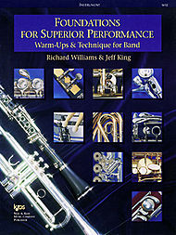
Required Materials:

Woodwinds (Flute, Saxophone, Clarinet):
- 1 Box of Rico size 2 ½ or 3 reeds (Saxophone and Clarinet)
- Cork Grease (Saxophone and Clarinet only)
- Instrument Cleaning Kit

Brass (Trumpet, Horn, Baritone, Tuba, Trombone):
- 1 Bottle of Valve Oil (Trumpet, Baritone, Tuba, Horn only)
- 1 Bottle of Slide Oil (Trombone only)
- Instrument Cleaning Kit

Percussion
- Vic Firth EP2*** (please do not get the EP1 set) Intermediate Education Pack includes:
  - BSB Stick Bag
  - SD1 Snare Drum Sticks
  - M3 Medium Hard Yarn Marimba Mallets
  - M6 Hard Plastic 1" Bell Mallets
  - T3 Staccato Timpani Mallets
More Information Available at:
www.chmsband.com
- Remo Practice Pad 8 Inches
All Students
- 1 One Inch Three-Ring Binder
- 50 Clear Plastic Sheet Protectors

